**Nail Salon Management System**

**Deliverable 3: Design Phase**

Derek Luong, Thomas Zhang, Spencer Wilkins, Asad Khan, Hamza Mir, Salman Khan

IS 436

Structured System Analysis and Design (04.8331)

November 7th, 2019

**Level 0: Diagram**

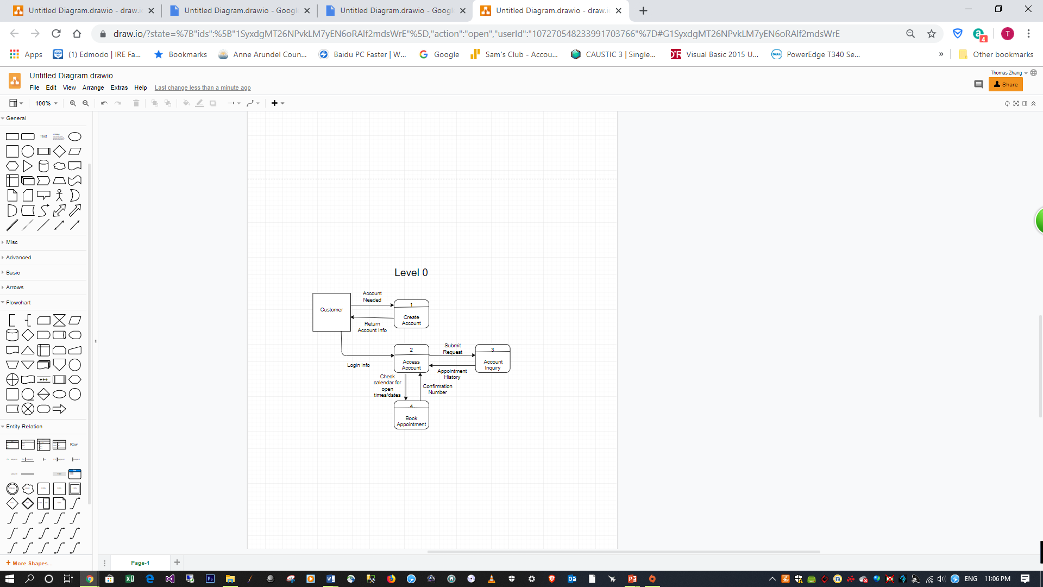

**Level 1: Diagram**

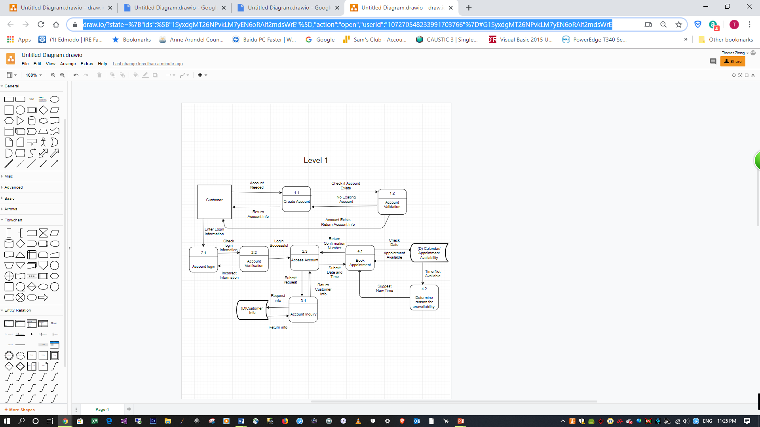

**Level 1 - Process: Create Account**

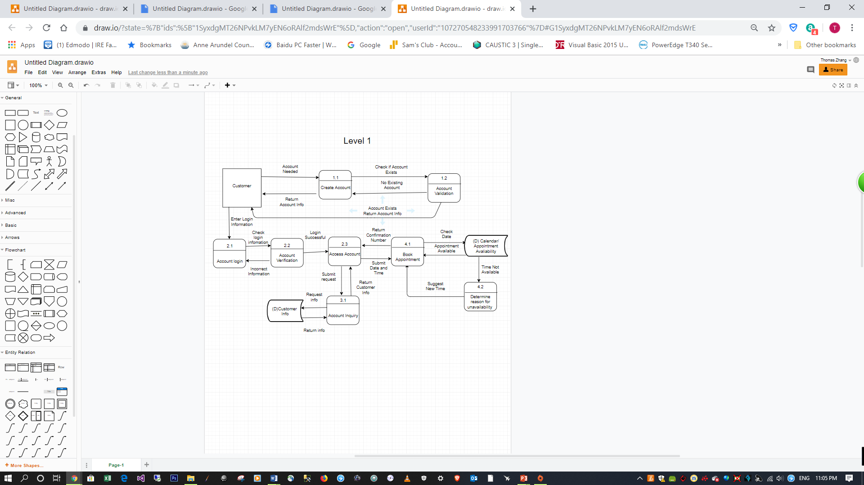

**Level 1 - Process: Accessing Account**

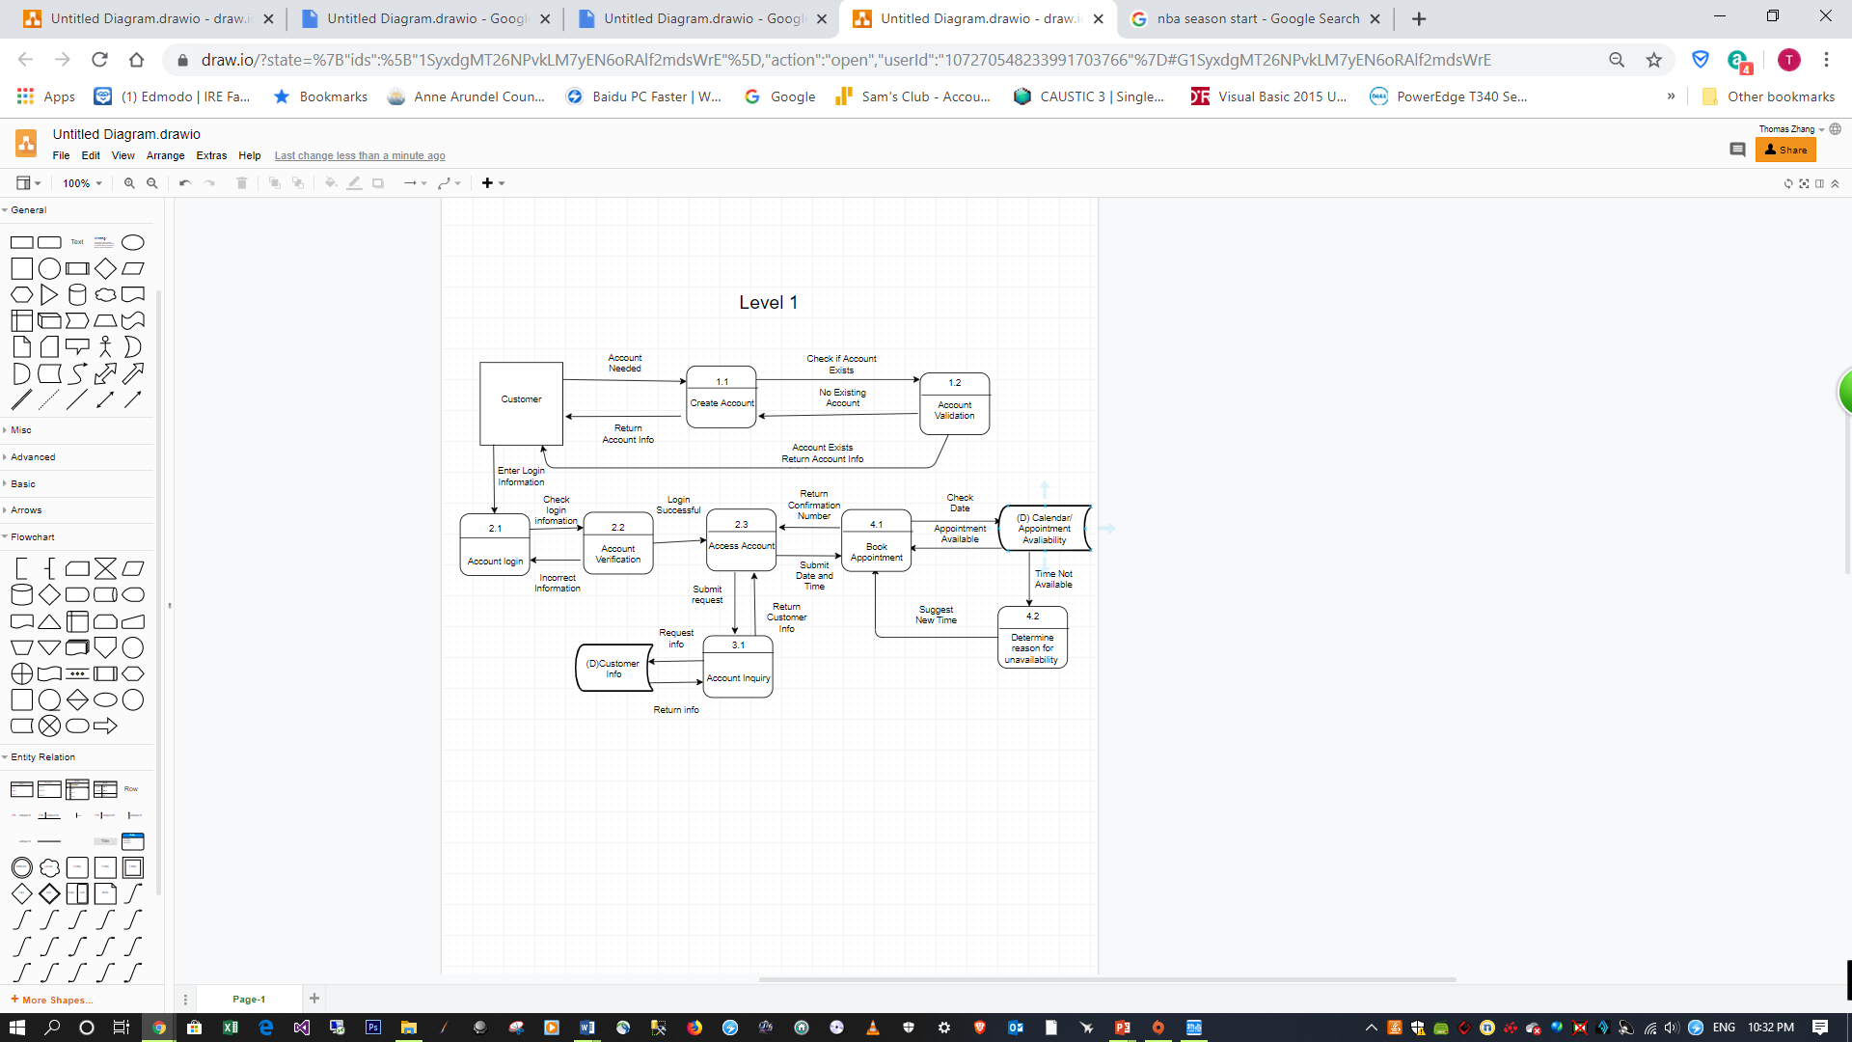

**Level 1 - Process: Account Inquiry**



**Level 1 - Process: Book Appointment**



**Text Definitions**

**Level 0:**

***Entities***

**Customer** - Person that is purchasing a service in the business.

**Employee** - Person working at business that has access to database system

***Processes***

**Create Account** - Process will create a user account for the customer if one has not yet yet been created for them.

***Access Account*** - Process will allow user to login to created account

**Account Inquiry** - Process will allow customer to request and receive information about their account

**Book Appointment** - Process will allow customer to look at company calendar and book an appointment date that is open.

***Dataflow***

**Account Needed** - customer request the need for account creation

**Return Account Info** - customer creates account and system sends the customer a notification that account has been created

**Login Info** - Customer attempts to login to account

**Submit Request** - Customer requests to look at account information

**Appointment History** - customer information regarding appointment information is returned

**Check Calendar Open Times/Date** - Customer searches calendar for open appointment times

**Confirmation Number** - customer reserves appointment and system sends confirmation number to customer

**Level 1**

***Entities***

Same as level 0

***Processes***

**Create Account** - Same as Level 0

**Account Validation** - System will check if user is creating an account that already exists via email

**Account Login** - Customer will use login information to login to account

**Account Verification** - Customer login information will be verified for correctness

**Access Account** - Same as Level 0

**Account Inquiry -** Same as Level 0

**Customer Info** - System will find and retrieve customer information from database

**Book Appointment -** Same as Level 0

**Calendar/Appointment Availability** - System will use customer inputted date and time to check the calendar for availability

**Determine Reason for Unavailability** - System will determine the reason for unavailability and will send the user the reason along with suggestion for new time

***Dataflow***

**Account Needed** - customer requests the need for account creation

**Return Account Info** - customer creates account and the system will send the customer a notification that the account has been created

**Check if account exists** - User will submit account information to the system and the system will check if a previous account exists.

**No existing account** - If no account exists then new account will be created with customer information that was given

**Account exists return account info** - If account exists then customer will be asked to input existing account info

**Enter Login Info** - Customer will enter account login information

**Check Login Info** - Login information will be checked for correctness

**Incorrect Info** - The login information inputted was not correct and an error message will be sent to user

**Login Successful** - The login information was correct and the user will be able to access account

**Submit Request** - User submits request to access account inquiry

**Return Customer Info** - Customer information is returned

**Request Info** - System receives customer request to access information

**Return Info** - System retrieves customer information

**Submit Date and Time** - Customer looks for appointment using date/time

**Return Confirmation Number** - customer reserves appointment and the system sends confirmation number for appointment to customer

**Check Date** - System will check to see if time is available on calendar

**Appointment Available** - System sends message to customer that the chosen date/time is available for reservation

**Time not available** - System checks appointment time availability and determines it is not available

**Suggest New Time** - System tells customers to suggest a different time

**Updated Requirement Documentation**

|  |  |
| --- | --- |
| **Functional Requirement** | **Requirements** |
| 1. Process Oriented | 1.1.) Ability for Customers to book appointments with nail tech by name and pay for the service  1.2.) Ability for customer to book appointment by viewing for vacancy on calendar..  1.3.) Creation of a link between the web app and the database. This will allow the customers to access this site and create an account that will offer certain benefits.  1.4) Customer should be able to create account if one does not exist |
| 2.) Information Oriented | 2.1.) Able to organize customer information name, age, address, etc. and will be able to keep track of customer transactions along with warranty information.  2.2.) Specify details relating to the business such as opening/closing times and the business address.  2.3) Customer can view information on account such as appointment history and personal info |

|  |  |
| --- | --- |
| **Nonfunctional Requirement** | **Requirements** |
| 1. Operational | 1.1.) The system should be compatible with any web browser.  1.2.) Should be able to run on android and iPhones. |
| 1. Performance | 2.1.) The system should be available for use 24 hours per day, 365 days per year.  2.2.) The system should update within 10 minutes of a change.  2.3.) The system must support 150 users from 8:30 a.m–5 p.m.; 50 users at all other times. |
| 1. Security | 3.1.) Nail technicians/workers can only see their sales/assignments.  3.2.) Only managers/owner can see each workers sales, assignments.  3.3.) Only owner can approve new customization options.  3.4.) System should have a firewall and all protection needed from viruses.  3.5.) Customer account login is kept secure. |
| 1. Cultural and Political | 4.1.) Company buys all technology from hp.  4.2.) Personal information is protected under the Privacy Law. |

**Updated Use Cases**

|  |  |  |  |
| --- | --- | --- | --- |
| **Use-case ID:** | **UC-1** | | |
| Use-case Name: | Creation of User Account | | |
| Created By: | Spencer and Asad | Last Updated By | Spencer |
| Date Created: | 10/16/2016 | Date Last Updated | 10/17/2019 |
| Actor: | Customer or Employee | | |
| Description: | Creation of a user account for use to store records, generate invoices, and track reward points. The customer information is entered and assigned a unique ID after validation if they do not already have an account. | | |
| Preconditions: | 1. Customer Doesn’t have an Account | | |
| Postconditions: | 1. Account Number is shown    1. Either from the newly created account or the located existing account. | | |
| Priority: | High | | |
| Frequency of Use: | Very Frequent | | |
| Normal Course of Events: | 1.0 Request the creation of a new account  1. Enter customer information (Name, Address, and Phone Number).  2. Validate information and check for prior records.   1. If an account is located return the original account number to the user.   3. Create new account if no pre-existing accounts are located. | | |
| Alternative Courses: |  | | |
| Exceptions: | E1) Account already exists (Occurs on Step 2)   1. Upon locating that the customer has an existing account return the account number for the original account to the customer. | | |
| Includes: |  | | |
| Special Requirements: | None | | |
| Assumptions: |  | | |
| Notes and Issues: | We want the customer to be able to create an account on their own via the company website or by having an associate create it for them either in the store or over the phone. This will allow the business to run more effectively and allow the customer to have better access to the salon’s services | | |

|  |  |  |  |
| --- | --- | --- | --- |
| **Use-case ID:** | **UC-2** | | |
| Use-case Name: | Book an appointment | | |
| Created By: | Asad and Spencer | Last Updated By | Spencer |
| Date Created: | 10/16/2016 | Date Last Updated | 10/17/2019 |
| Actor: | Customer or Employee | | |
| Description: | Set an appointment before reaching the store or you can set an appointment. Also able to pick our favorite employee to get your nails done | | |
| Preconditions: |  | | |
| Post conditions: | 1. Confirmation of appointment, or lack thereof, is given.    1. Includes date, time, and employee. | | |
| Priority: | High | | |
| Frequency of Use: | Very Frequent | | |
| Normal Course of Events: | 1.0 create an appointment  1. Select your date and time and enter Account Number   1. If they do not have an account number offer them the ability to create an account while booking the appointment - See Use Case 1   2. Validate employee availability  a.If no employees are available for client please ask them to select another date and time  3. Enter the desired procedure  4. Validate that there is enough time to perform the service and that proper inventory exists.   1. If there isn’t enough time or inventory recommend another time.   5. Return confirmation that the appointment is scheduled and give a confirmation number. | | |
| Alternative Courses: |  | | |
| Exceptions: | E1) No account number for the customer (Occurs at step 1)   1. Customer is missing an account number 2. Offer the option to sign up and create an account at the same time with additional information 3. If declined, provide the availability to reserve using alternative information without storing rewards points.   E2) No Employees available during the desired time (Happens at step 2)   1. Determine why no employees are available. 2. Check the hours and ensure the store is open.    1. If Store is closed return the hours the salon is open 3. Check if all employees have been booked    1. Return a message offering other times available   E3) Not enough time for a desired procedure (Occurs at step 4)   1. Check the average length of the procedure and ensure there is enough time prior to closing and next appointment. 2. If there is not enough time then inform the customer and suggest a more appropriate time and let the customer know the length of the service | | |
| Includes: |  | | |
| Special Requirements: |  | | |
| Assumptions: | An account number is recommended for benefits, but not required as alternative methods of identification would be allowed. | | |
| Notes and Issues: |  | | |

We want the customer to be able to book an appointment online, over the phone, or in person. They are free to select the date, time, and employee from a list of available employees.

|  |  |  |  |
| --- | --- | --- | --- |
| **Use-case ID:** | **UC-3** | | |
| Use-case Name: | Account Log In and Authorization | | |
| Created By: | Spencer and Thomas | Last Updated By | Spencer |
| Date Created: | 10/16/2016 | Date Last Updated | 10/17/2019 |
| Actor: | Customer or Employee | | |
| Description: | Use Case for account log in and validation. Will provide access to the appropriate functions based on the account type. | | |
| Preconditions: | 1. The user, either the employee or the customer, already has an account. | | |
| Post conditions: | 1. The user will be logged in and have access to their account’s roles upon successful login | | |
| Priority: | High | | |
| Frequency of Use: | Very Frequent | | |
| Normal Course of Events: | 1.0) Account Log in and Validation   1. From main page, select the option to log in. 2. Display a prompt for logging in with account and password. 3. User enters their account information 4. Validate that correct account information was entered    1. If incorrect information was entered display a notification which includes the option to recover or create an account and return to step 1 5. Once validated, display a success message and access to the functions based on their roles. | | |
| Alternative Courses: | AC1) Doesn’t have an Account (Occurs at Step 2 and 4)   1. If the user goes to login and they do not have an account they can select an option to create an account. | | |
| Exceptions: | EC1) Incorrect Account Information Entered (Occurs at step 4)   1. Incorrect information is entered 2. Error message is displayed which contains the option to recover an account or create an account. 3. Upon acknowledging the error message they are returned to step 1 and prompted to log in again. | | |
| Includes: |  | | |
| Special Requirements: |  | | |
| Assumptions: | 1. The user has an account 2. The same login portal will be used for both employees and customers | | |
| Notes and Issues: | The users need to log in to the system in order to see information specific to them. Employees will be able to see all of their appointments and clients. Customers will be able to see their account information, historic appointments / services, and upcoming appointments. | | |

|  |  |  |  |
| --- | --- | --- | --- |
| **Use-case ID:** | **UC-4** | | |
| Use-case Name: | Account Inquiry | | |
| Created By: | Spencer and Thomas | Last Updated By | Spencer |
| Date Created: | 10/16/2016 | Date Last Updated | 10/17/2019 |
| Actor: | Customer or Employee | | |
| Description: | Use Case for account log in and validation. Will provide access to the appropriate functions based on the account type. | | |
| Preconditions: | 1. The user has an account 2. The user has logged in through use case UC_3 | | |
| Post conditions: |  | | |
| Priority: | High | | |
| Frequency of Use: | Very Frequent | | |
| Normal Course of Events: | 1.0) Account Inquiry   1. Upon logging in to the account, click on the option “Appointments” 2. A Calendar will pull up that will display all of the appropriate appointments.    1. For employees this will show all of their past and upcoming appointments with customer information and selected service.    2. For customers this will show their past and future appointments with service and employee who performed the service 3. The calendar would be displayed in a month to month view but could be changed to weekly. | | |
| Alternative Courses: | AC1) Employee View (Occurs at step 2)   1. An employee logging in will see much more information on their calendar.    1. They would see all of the appointments, past or present, on their schedule 2. Each day would display the number of appointments broken up by service type. 3. They can change their view by clicking on a week and bring up a larger view of each day.    1. In this view, the information displayed would contain the customer information, service time, and time frame for each appointment.   AC2) Customer View (Occurs at step 2)   1. A customer logging in would see a month at a time 2. On days they have appointments it would show the time, service, confirmation number, and employee with whom they have an appointment. 3. They can change their view to a weekly view as well but the same information is displayed. | | |
| Exceptions: |  | | |
| Includes: |  | | |
| Special Requirements: |  | | |
| Assumptions: | 1. The user must have an account. 2. The employees need access to more information on a day to day basis in order to perform their job proficiently. | | |
| Notes and Issues: | The employees need to see and have access to a larger amount of information. The functionality of being able to restrict the view to just a week, in order for them to see more specific information in a readable and accessible, was designed with the employees in mind. However, if the same log in portal is used and the same function for checking the appoints is used for both employees and customers there isn’t a reason why it can’t be given to both parties. The information shown would be different.  The customer can use this feature to request a specific employee, or avoid an employee, if they liked or disliked a past appointment | | |

**Project Plan**

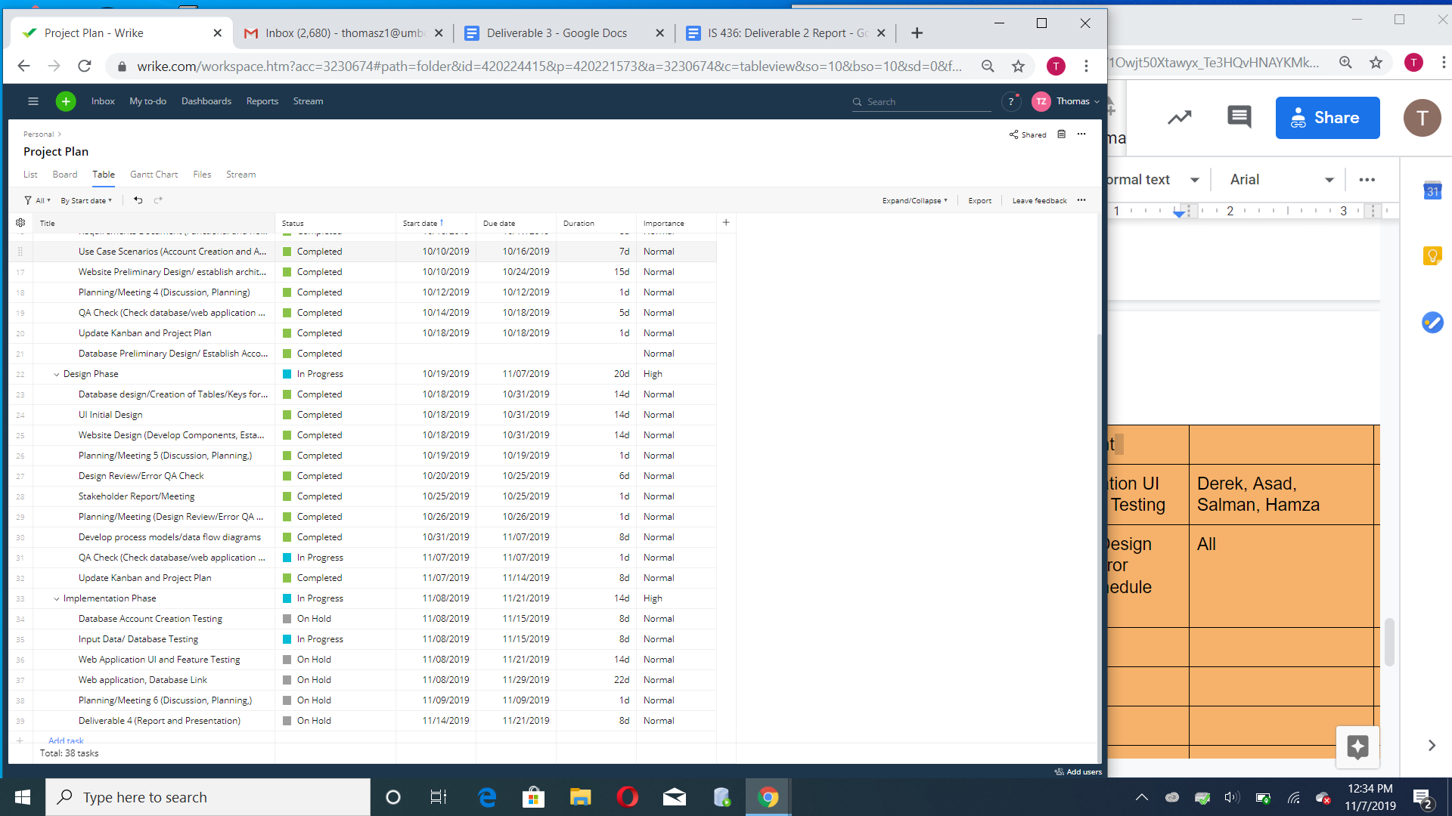

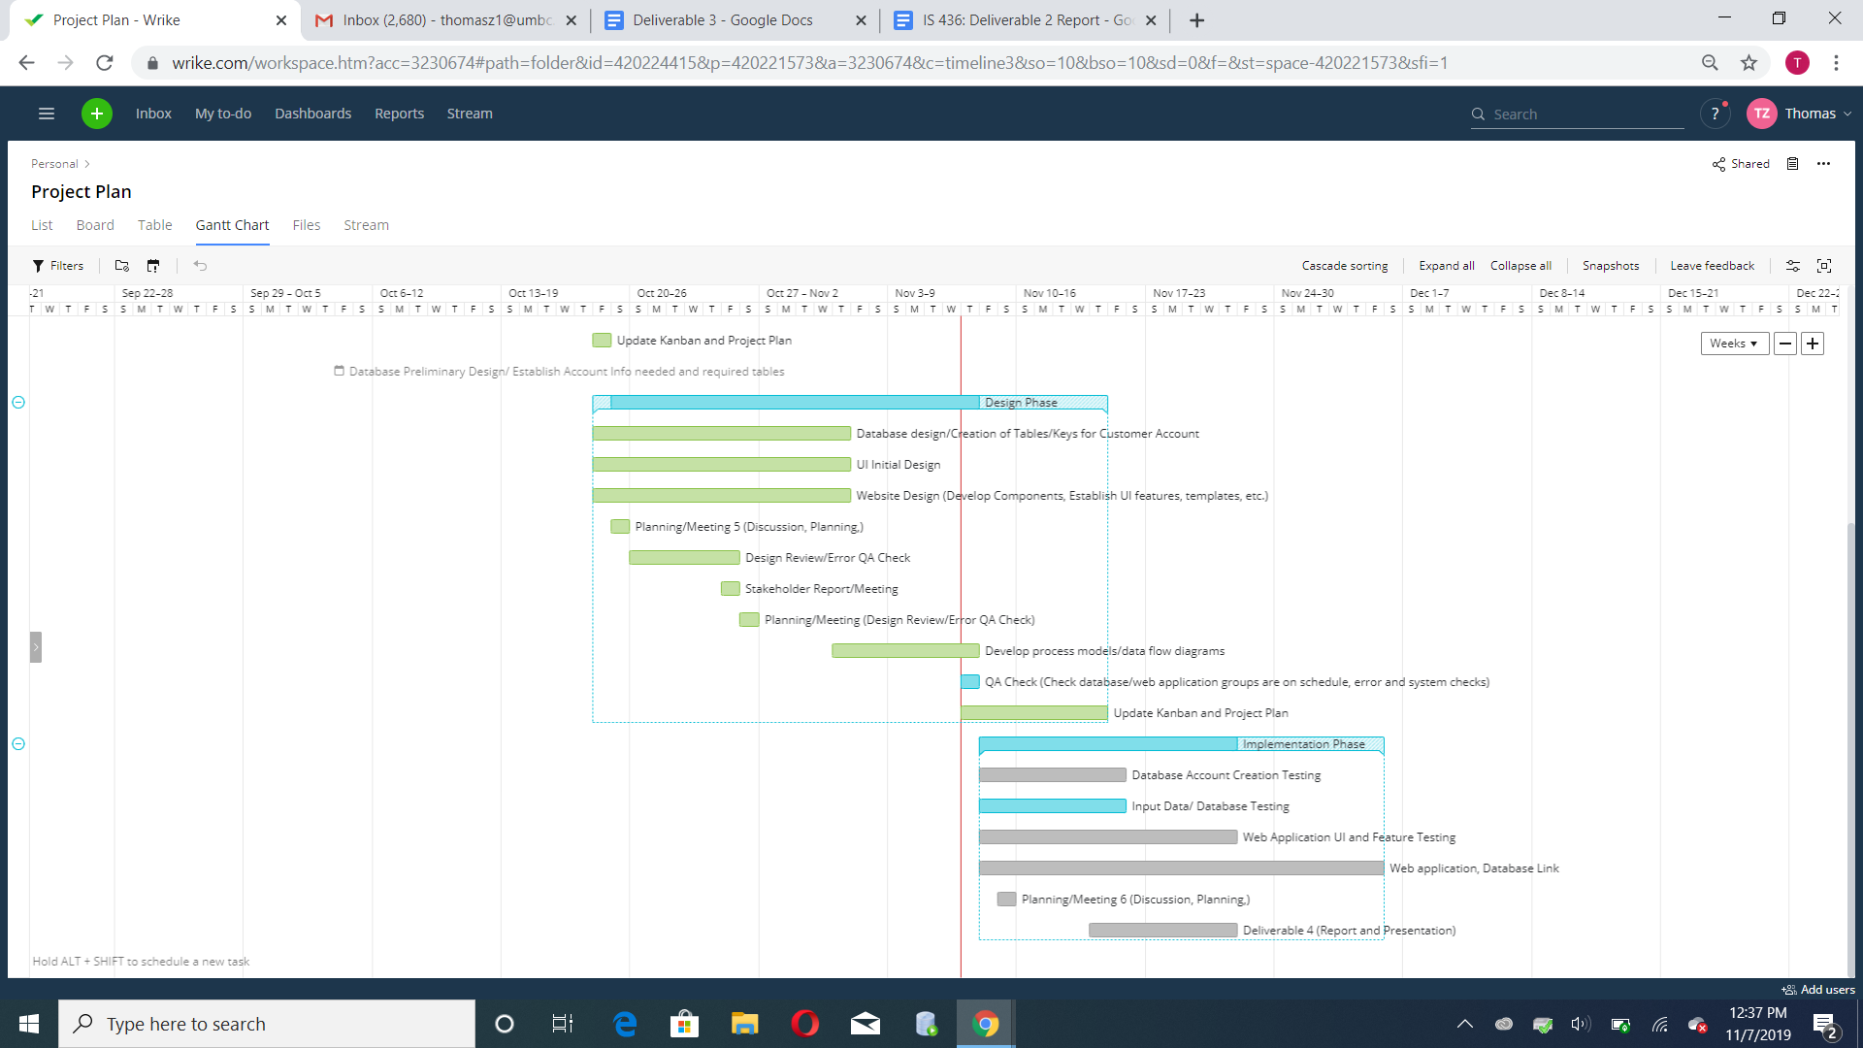

**Kanban Board**

